# VISVESVARAYA TECHNOLOGICAL UNIVERSITY

## BELAGAVI – 590018, Karnataka INTERNSHIP REPORT

#### ON

“SMART HOME CONTROL DASHBOARD”

***Submitted in partial fulfilment for the award of degree of***

## BACHELOR OF ENGINEERING

## IN

## COMPUTER SCIENCE ENGINEERING

***Submitted by:***

#### CHINMAY CK

#### 1JB21CS029

Conducted at

**VARCONS TECHNOLOGIES Pvt Ltd**

**SJB INSTITUTE OF TECHNOLOGY**

No.67, BGS Health & Education City, Dr.Vishnuvardhan Rd, Kengeri, Bengaluru, Karnataka 560060

|| Jai Sri Gurudev ||

Sri Adichunchanagiri Shikshana Trust ®

**SJB INSTITUTE OF TECHNOLOGY**

## No.67, BGS Health & Education City, Dr.Vishnuvardhan Rd, Kengeri, Bengaluru, Karnataka 560060

**Department of Computer Science and Engineering**



**CERTIFICATE**

This is to certify that the Internship titled “Smart Home Control Dashboard” carried out by **CHINMAY C K**, a bonafide student of SJB Institute of Technology, in partial fulfillment for the award of Bachelor of Engineering, in **COMPUTER SCIENCE ENGINEERING** under Visvesvaraya Technological University, Belagavi, during the year 2023-2024. It is certified that all corrections/suggestions indicated have been incorporated in the report.

The project report has been approved as it satisfies the academic requirements in respect of Internship prescribed for the course Internship / Professional Practice (21INT68)

|  |  |  |
| --- | --- | --- |
| Dr. Veena H N  **Assistant Professor** | Dr. Krishna A N  **Professor & Head** | Dr. K V Mahendra Prashanth  **Principal** |
| **Dept. of CSE, SJBIT** | **Dept. of CSE, SJBIT** | **SJBIT** |

**External Viva:**

Name of the Examiner Signature with Date

1)

2)

# D E C L A R A T I O N

I, **CHINMAY C K**, third year student of CSE, SJB Institute of Technology - 560 060, declare that the Internship has been successfully completed, in Varcons Technologies Pvt Ltd. This report is submitted in partial fulfillment of the requirements for award of Bachelor of Engineering Degree in CSE, during the academic year 2022-2023.

Date :01-12-2023 :

Place: Bengaluru

USN: 1JB21CS029

NAME: CHINMAY C K

**OFFER LETTER PROVIDED BY THE COMPANY**

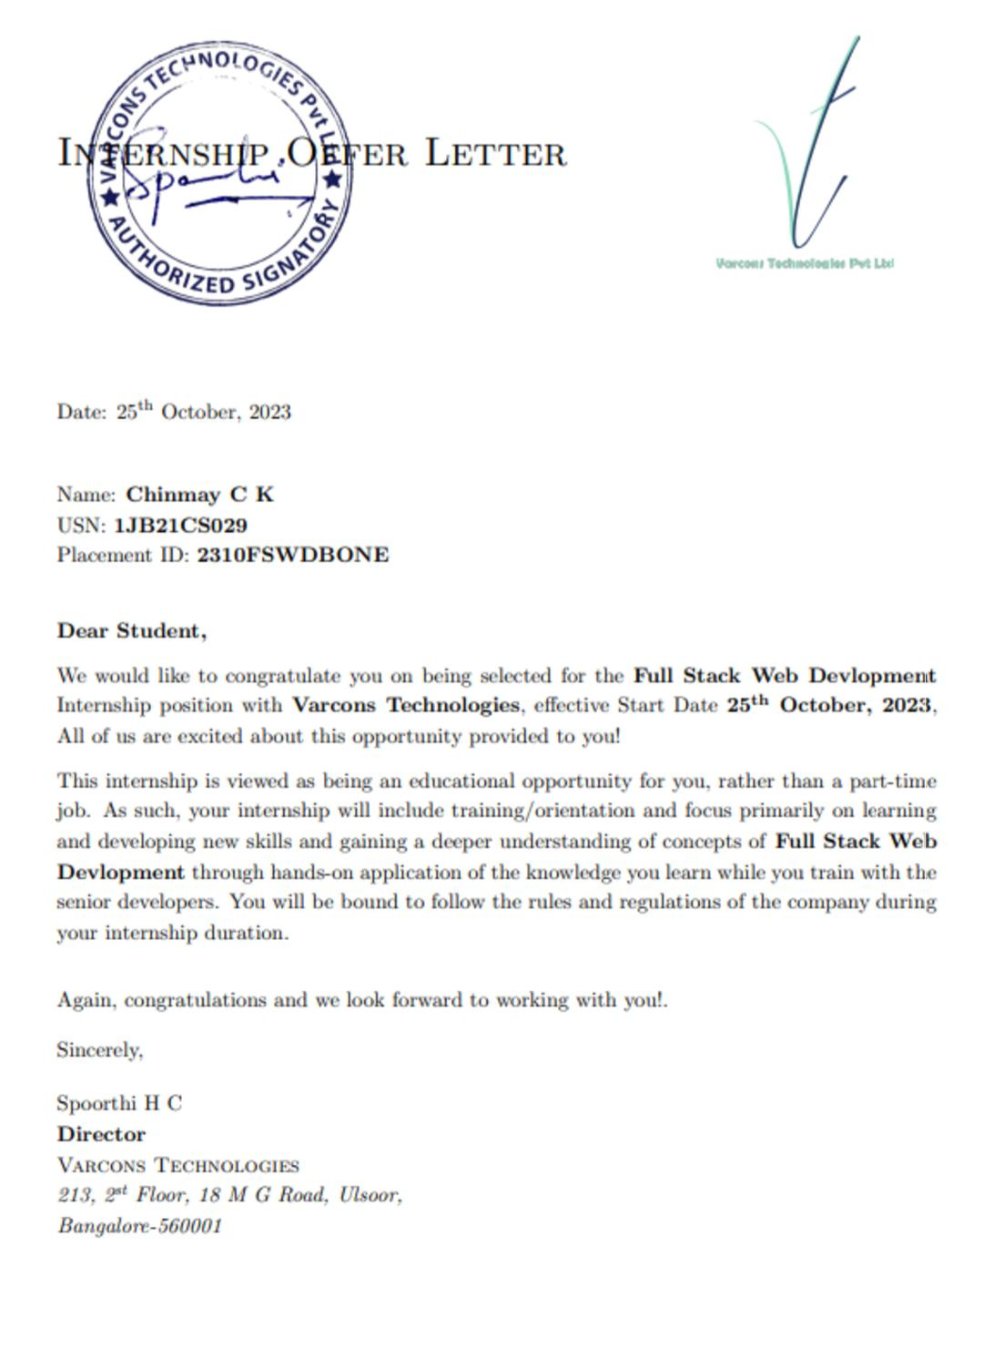

# A C K N O W L E D G E M E N T

This Internship is a result of accumulated guidance, direction and support of several important persons. We take this opportunity to express our gratitude to all who have helped us to complete the Internship.

We express our sincere thanks to **Dr. K. V. Mahendra Prashanth,** Principal, SJB Institute of Technology, for providing us adequate facilities to undertake this Internship.

We would like to thank our **Dr. Krishan A N,** Head of the Department, Computer Science and Engineering, for providing us an opportunity to carry out Internship and for his valuable guidance and support.

We would like to thank our trainer at Varcons Technologies Software Services for guiding us during the period of internship.

We express our deep and profound gratitude to our guide **Dr. Veena H N,** Assistant professor, Dept of CSE for her keen interest and encouragement at every step in completing the Internship.

We would like to thank all the faculty members of our department for the support extended during the course of Internship.

We would like to thank the non-teaching members of our dept, for helping us during the Internship.

Last but not the least, we would like to thank our parents and friends without whose constant help, the completion of Internship would have not been possible.

**CHINMAY CK**

**1JB21CS029**

# ABSTRACT

The evolution of smart home technology has paved the way for innovative control dashboards that provide users with intuitive and efficient management of their connected devices. This report delves into the design and development of a reimagined smart home control dashboard, emphasizing enhanced user convenience and seamless device integration.

The proposed smart home control dashboard goes beyond conventional interfaces by incorporating cutting-edge features and responsive design.

Key elements of the system include an adaptive user interface that evolves based on usage patterns, real-time device status updates, and a minimalist user interface. The dashboard prioritizes simplicity and customization, allowing users to tailor their control preferences and create personalized automation scenarios.

Furthermore, the report evaluates the system's performance through usability studies, feedback from users, and metrics assessing response times, device synchronization, and overall user satisfaction. By emphasizing user-centric design and intelligent automation, the goal is to showcase the effectiveness of this reimagined smart home control dashboard in providing a streamlined and enjoyable experience for homeowners navigating the complexities of the modern connected home.

# Table of Contents

|  |  |  |
| --- | --- | --- |
| **Sl no** | **Description** | **Page no** |
| 1 | Company Profile | 8 |
| 2 | About the Company | 10 |
| [3](https://1.bp.blogspot.com/-dODuK8N5h1Q/Wlnyb3V9HFI/AAAAAAAACL4/WxQtCJ1pM5wccDABg4wIrTBUB0vlikXQQCLcBGAs/s1600/poly1.jpg) | Introduction | 14 |
| [4](https://1.bp.blogspot.com/-dODuK8N5h1Q/Wlnyb3V9HFI/AAAAAAAACL4/WxQtCJ1pM5wccDABg4wIrTBUB0vlikXQQCLcBGAs/s1600/poly1.jpg) | System Analysis | 17 |
| [5](https://1.bp.blogspot.com/-dODuK8N5h1Q/Wlnyb3V9HFI/AAAAAAAACL4/WxQtCJ1pM5wccDABg4wIrTBUB0vlikXQQCLcBGAs/s1600/poly1.jpg) | Requirement Analysis | 21 |
| 6 | Design [Analysis](https://4.bp.blogspot.com/-IOOxgPaXMVc/Wlj3LWvcnjI/AAAAAAAACKE/UeTFYvAxDmUDel5UBjdifeWaApB3-dXVgCLcBGAs/s1600/img1.jpg) | 25 |
| 7 | [Implementation](https://4.bp.blogspot.com/-IOOxgPaXMVc/Wlj3LWvcnjI/AAAAAAAACKE/UeTFYvAxDmUDel5UBjdifeWaApB3-dXVgCLcBGAs/s1600/img1.jpg) | 28 |
| 8 | Snapshots | 31 |
| 9 | Conclusion | 40 |
| 10 | References | 42 |

[**CHAPTER**](https://1.bp.blogspot.com/-dODuK8N5h1Q/Wlnyb3V9HFI/AAAAAAAACL4/WxQtCJ1pM5wccDABg4wIrTBUB0vlikXQQCLcBGAs/s1600/poly1.jpg) **1** **COMPANY PROFILE**

# COMPANY PROFILE

**History of the Organization**

Varcons Technology Private Limited is a Varcons Technologies registration held business entity registered under The Companies Act, 2013. It’s registered for pre-defined objects or activity Computer and related activities as per Activity Code mentioned under Varcons Technologies CIN Number U72900KA2022PTC163646. Varcons Technologies has paid up capital Rs. 10000 and Authorized Capital Rs. 1000000. It is set up directly by registering the Varcons Technologies with RoC, Ministry of Corporate Affairs. Its registered office address is 8/9 5th Main 3rd Cross road Beside Sachidananda Nagar R R Nagar Bangalore KA 560098 IN. Private Limited Varcons Technologies registration is registered in2022-07-11, India and Registrar of Varcons Technologies is RoC - Bangalore. it is non-govt Varcons Technologies. Private Limited Varcons Technologies registration Varcons Technologies has paid up capital Rs. 10000 and Authorized Capital Rs. 1000000

**Objectives**

* Main goal is to find smart ways of using technology that will help build a better tomorrow for everyone, everywhere and to offers a variety of advantages over traditional software licensing models and here at VCT tend to include the key features of SaaS in everything to build.
* To deliver high-quality, customized web design and development solutions that meet or exceed our clients’ expectations and achieve their business goals.
* To stay up to date with industry standards and best practices, and to ensure that our web design and development solutions comply with all relevant regulations and guidelines
* To understand customer requirements and fulfill them.
* Increase the assets and investments of the organization to support the development of services and expansion of the organization.
* To increase productivity and improve customer service satisfaction.
* To do innovations in the Software field and provide quality services to deliver a range of products.

# [CHAPTER](https://1.bp.blogspot.com/-dODuK8N5h1Q/Wlnyb3V9HFI/AAAAAAAACL4/WxQtCJ1pM5wccDABg4wIrTBUB0vlikXQQCLcBGAs/s1600/poly1.jpg) 2 ABOUT THE COMPANY

1. **ABOUT THE COMPANY**

Varcons Technologies is a Technology Organization providing solutions for all web design and development, MYSQL, PYTHON Programming, HTML, CSS, ASP.NET and LINQ. Meeting the ever increasing automation requirements, Varcons Technologies specialize in ERP, Connectivity, SEO Services, Conference Management, effective web promotion and tailor-made software products, designing solutions best suiting clients requirements. The organization where they have a right mix of professionals as a stakeholder to help us serve our clients with best of our capability and with at par industry standards. They have young, enthusiastic, passionate, and creative Professionals to develop technological innovations in the field of Mobile technologies, Web applications as well as Business and Enterprise solution. The motto of our organization is to “Collaborate with our clients to provide them with the best Technological solution hence creating Good Present and Better Future for our client which will bring a cascading a positive effect in their business shape as well”. Providing a Complete suite of technical solutions is not just our tag line, it is Our Vision for Our Clients and for Us, we strive hard to achieve it.

## Products of Varcons Technologies.

**Android Apps**

It is the process by which new applications are created for devices running the Android operating system. Applications are usually developed in Java (and/or Kotlin; or other such option) programming language using the Android software development kit (SDK), but other development environments are also available, some such as Kotlin support the exact same Android APIs (and bytecode), while others such as Go have restricted API access.

The Android software development kit includes a comprehensive set of development tools. These include a debugger, libraries, a handset emulator based on QEMU, documentation, sample code, and tutorials. Currently supported development platforms include computers running Linux (any modern desktop Linux distribution), Mac OS X 10.5.8 or later, and Windows 7 or later. As of March 2015, the SDK is not available on Android itself, but software development is possible by using specialized Android applications.

**Web Application**

It is a client–server computer program in which the client (including the user interface and client- side logic) runs in a web browser. Common web applications include web mail, online

retail sales, online auctions, wikis, instant messaging services and many other functions. web applications use web documents written in a standard format such as HTML and JavaScript, which are supported by a variety of web browsers. Web applications can be considered as a specific variant of client–server software where the client software is downloaded to the client machine when visiting the relevant web page, using standard procedures such as HTTP. The Client web software updates may happen each time the web page is visited. During the session, the web browser interprets and displays the pages, and acts as the universal client for any web application. The use of web application frameworks can often reduce the number of errors in a program, both by making the code simpler, and by allowing one team to concentrate on the framework while another focuses on a specified use case. In applications which are exposed to constant hacking attempts on the Internet, security- related problems can be caused by errors in the program.

Frameworks can also promote the use of best practices such as GET after POST. There are some who view web applications as a two-tier architecture. This can be a “smart” client that performs all the work and queries a “dumb” server, or a “dumb” client that relies on a “smart” server. The client would handle the presentation tier, the server would have the database (storage tier), and the business logic (application tier) would be on one of them or on both. While this increases the scalability of the applications and separates the display and the database, it still doesn’t allow for true specialization of layers, so most applications will outgrow this model. An emerging strategy for application software companies is to provide web access to software previously distributed as local applications. Depending on the type of application, it may require the development of an entirely different browser-based interface, or merely adapting an existing application to use different presentation technology. These programs allow the user to pay a monthly or yearly fee for use of a software application without having to install it on a local hard drive. A company which follows this strategy is known as an application service provider (ASP), and ASPs are currently receiving much attention in the software industry.

Security breaches on these kinds of applications are a major concern because it can involve both enterprise information and private customer data. Protecting these assets is an important part of any web application and there are some key operational areas that must be included in the development process. This includes processes for authentication, authorization, asset handling, input, and logging and auditing. Building security into the applications from the beginning can be more effective and less disruptive in the long run.

**Web design**

It is encompassing many different skills and disciplines in the production and maintenance of websites. The different areas of web design include web graphic design; interface design; authoring, including standardized code and proprietary software; user experience design; and

search engine optimization. The term web design is normally used to describe the design process relating to the front-end (client side) design of a website including writing mark up. Web design partially overlaps web engineering in the broader scope of web development. Web designers are expected to have an awareness of usability and if their role involves creating markup then they are also expected to be up to date with web accessibility guidelines. Web design partially overlaps web engineering in the broader scope of web development.

## Departments and services offered

Varcons Technologies plays an essential role as an institute, the level of education, development of student’s skills are based on their trainers. If you do not have a good mentor then you may lag in many things from others and that is why we at Varcons Technologies gives you the facility of skilled employees so that you do not feel unsecured about the academics. Personality development and academic status are some of those things which lie in a mentor’s hands. If you are trained well then you can do well in your future and knowing its importance of Varcons Technologies always tries to give you the best.

They have a great team of skilled mentors who are always ready to direct their trainees in the best possible way they can and to ensure the skills of mentors we held many skill development programs as well so that each and every mentor can develop their own skills with the demands of the companies so that they can prepare a complete packaged trainee.

## Services provided by Varcons Technologies.

* Core Java and Advanced Java
* Web services and development
* Dot Net Framework
* Python
* Selenium Testing
* Conference / Event Management Service
* Academic Project Guidance
* On The Job Training
* Software Training

# [CHAPTER](https://1.bp.blogspot.com/-dODuK8N5h1Q/Wlnyb3V9HFI/AAAAAAAACL4/WxQtCJ1pM5wccDABg4wIrTBUB0vlikXQQCLcBGAs/s1600/poly1.jpg) 3 INTRODUCTION

1. **INTRODUCTION**

In today's digital age, the management and control of smart home devices have evolved beyond basic functionality to offer a personalized and seamless experience. The emergence of smart home control dashboards has transformed how individuals interact with and oversee their home automation systems. However, with the increasing complexity of smart home ecosystems, users often encounter the daunting task of efficiently managing and monitoring their devices to align with their unique preferences and routines.

To address this challenge, an intuitive smart home control dashboard leveraging full-stack web development emerges as a solution. This system embodies an amalgamation of advanced technologies, user-friendly interfaces, and intelligent functionalities to empower users with effortless and personalized control over their smart home environment.

**System Overview**

The smart home control dashboard operates as an interconnected web of front-end technologies, aiming to provide a user-centric approach to efficiently manage and monitor smart home devices. It focuses on deciphering individual preferences and needs through comprehensive user interactions, offering a seamless and personalized control experience for the users.

**Front-End Experience**

The front-end component of the smart home control dashboard embodies a visually engaging and user-friendly interface, meticulously designed to simplify the user's experience in managing and monitoring smart home devices. Through a blend of HTML, CSS, and JavaScript frameworks such as React or Angular, users are greeted with an immersive interface that beckons seamless control and monitoring of their smart home environment.

This interface encourages users to input their preferences, whether it's specific device controls, settings, or automation routines. With intuitive design elements and seamless navigation, users effortlessly interact with the system, providing essential inputs that serve as the foundation for personalized smart home device management and control.

In addition to the visually engaging and user-friendly interface, the smart home control dashboard's front-end component is designed to provide a smooth and intuitive experience for users interacting with their smart home devices. The interface is crafted to enable users to effortlessly customize and control various aspects of their smart home environment, such as adjusting settings, managing devices, and creating automation routines. Through seamless navigation and interactive design elements, the dashboard empowers users to have full control over their smart home, catering to their specific preferences and needs.

# [CHAPTER](https://1.bp.blogspot.com/-dODuK8N5h1Q/Wlnyb3V9HFI/AAAAAAAACL4/WxQtCJ1pM5wccDABg4wIrTBUB0vlikXQQCLcBGAs/s1600/poly1.jpg) 4 SYSTEM ANALYSIS

**4. SYSTEM ANALYSIS**

**1.Front-End Analysis:**

* **User Interface (UI):**

The user interface of the smart home control dashboard incorporates various elements such as sliders, toggles, buttons, and input fields to enable seamless user interaction for managing and monitoring smart home devices. These UI elements are designed to provide intuitive controls for adjusting settings, activating devices, and creating automation routines within the smart home environment. Consideration is given to UI frameworks and libraries like React, Angular, or Vue.js, which play a significant role in ensuring the responsiveness and interactivity of the dashboard's interface.

* **Design and User Experience (UX):**

The design and user experience principles of the smart home control dashboard focus on streamlining the process of controlling and managing smart home devices. The user experience flow within the dashboard is carefully crafted to allow users to navigate through the system effortlessly, accessing and controlling various aspects of their smart home environment with ease. Additionally, usability testing and user feedback mechanisms are integrated to gather insights and refine the design, ensuring that the dashboard evolves to meet the specific needs and preferences of its users.

This analysis provides a comprehensive understanding of the front-end development considerations for the smart home control dashboard, emphasizing the importance of user interface design, interactivity, and user experience flow.

**2.Functionality:**

* **Device Control Logic:**

Description of Control Algorithms: This section outlines the underlying algorithms and logic employed for managing devices seamlessly through the dashboard. It emphasizes simplicity and efficiency, with a focus on HTML and CSS for an uncomplicated user interface.

* **Remote Device Connectivity:**

Highlighting the capability of the dashboard to establish and maintain connections with home devices from anywhere globally, ensuring users can oversee and control their smart home ecosystem even when abroad.

* **Overview of Device Status:**

Detailing how the dashboard provides a comprehensive overview of all connected devices and rooms within the home, promoting easy navigation and monitoring.

* **Power Consumption Metrics:**

Introducing features that allow users to monitor power consumption patterns, offering insights into energy usage and promoting eco-friendly practices.

**3. Security Analysis:**

* **Authentication and Authorization:**
* Explanation of how user authentication and authorization are implemented to ensure data security and user privacy.
* Use of encryption techniques (HTTPS, JWT, OAuth, etc.).

**4. Performance Analysis:**

* **User Volume Handling Assessment:**

An examination of the dashboard's proficiency in managing a substantial user base and concurrent device control requests.

* **Robustness under Load:**

Evaluating the system's resilience and effectiveness when subjected to varying loads, emphasizing its ability to maintain optimal performance even during peak usage.

**5.Testing and Quality Assurance:**

* **Testing Strategies:**
* Overview of testing methodologies (unit testing, integration testing, etc.) used to ensure system reliability and functionality.
* **Bug Tracking and Resolution:**
* Procedures for identifying, tracking, and resolving bugs or issues in the system.

**6.Deployment and Maintenance:**

* **Deployment Strategy:**
* Description of deployment environments (production, staging, development) and deployment tools (Docker, Kubernetes, etc.).
* **Maintenance Plan:**
* Outline of maintenance practices, including updates, patches, and system monitoring.

# [CHAPTER](https://1.bp.blogspot.com/-dODuK8N5h1Q/Wlnyb3V9HFI/AAAAAAAACL4/WxQtCJ1pM5wccDABg4wIrTBUB0vlikXQQCLcBGAs/s1600/poly1.jpg) 5 REQUIREMENT ANALYSIS

**5. REQUIREMENT ANALYSIS**

**Functional Requirements:**

**1. User Authentication and Authorization:**

* Seamless user registration and login procedures.
* Integration of authentication mechanisms, including email and social login, ensuring secure access.

**2. Device Management:**

* User-friendly interface for straightforward device connectivity and control.
* HTML and CSS design to ensure simplicity and accessibility.
* Remote accessibility for users overseas, facilitating device oversight and control from anywhere.

**3. Real-Time Device Overview:**

* Comprehensive dashboard overview of all connected devices and rooms within the home.
* Real-time updates on device status, ensuring users stay informed about the current state of their home**.**

**4. Power Consumption Monitoring:**

* Inclusion of features allowing users to monitor power consumption patterns.
* Ability to control and optimize device usage for efficient power management.

**5. User Interaction and Feedback:**

* User-friendly interface for intuitive device control and power management.
* Incorporation of feedback mechanisms, enabling users to provide input on device performance and functionality.

**6. Search and Filtering:**

* Search functionality for specific devices, rooms, or types of devices within the home.
* Filtering options for refining device results based on user preferences.

**Non-Functional Requirements:**

**1.Performance:**

* **Requirements:**
* Quick response times for playlist generation.
* Scalability to handle concurrent user requests.

**2.Security:**

* **Requirements:**
* Data encryption for user credentials and sensitive information.
* Protection against common web vulnerabilities (SQL injection, XSS attacks).

**3.Reliability:**

* **Requirements:**
* Minimal downtime for maintenance.
* Robust error handling and recovery mechanisms.

**4.Usability and User Experience:**

* **Requirements:**
* Intuitive and responsive user interface.
* Consistent design and navigation throughout the application.

**5.Compatibility:**

* **Requirements:**
* Compatibility across multiple devices and browsers.
* Responsive design for mobile devices.

**6.Scalability:**

* **Requirements:**
* Ability to scale the system with increasing user loads.

**7.Regulatory Compliance:**

* **Requirements:**
* Compliance with data protection regulations (GDPR, CCPA, etc.).

**8.Maintenance and Support:**

* **Requirements:**
* Documentation for system maintenance and updates.
* Provision for customer support or troubleshooting.

# [CHAPTER](https://1.bp.blogspot.com/-dODuK8N5h1Q/Wlnyb3V9HFI/AAAAAAAACL4/WxQtCJ1pM5wccDABg4wIrTBUB0vlikXQQCLcBGAs/s1600/poly1.jpg) 6 DESIGN ANALYSIS

1. **DESIGN & ANALYSIS**

**1. User Interface (UI/UX):**

* **Wireframing & Prototyping:** Create mockups and prototypes to visualize the user interface and functionality.
* **Responsive Design:** Ensure the interface adapts seamlessly across various devices and screen sizes.
* **Intuitive Interaction**: Design an intuitive user experience tailored for easy navigation, straightforward device control, and efficient power consumption monitoring

.**2. Front-end Development:**

* **HTML/CSS/JS:** Implement the UI using HTML for structure, CSS for styling, and JavaScript for interactivity.
* **Frameworks/Libraries:** Leverage frameworks such as React, Angular, or Vue.js for efficient front-end development.
* **API Integration: C**onnect with home devices using APIs to fetch real-time data on device status, power consumption, and room overviews.

**3. Dashboard Functionality:**

* **Device Overview:** Display a comprehensive overview of connected devices and rooms within the home, facilitating easy navigation and monitoring.
* **Power Consumption Monitoring:** Enable users to view and manage power consumption patterns, promoting energy-efficient practices.

**5. Additional Considerations:**

* **Performance Optimization:** Optimize code and database queries for faster response times and efficient data retrieval.
* **Scalability:** Design the system to handle increased user traffic and data volume as the user base grows.
* **Testing & Quality Assurance:** Conduct thorough testing (unit tests, integration tests, user acceptance tests) to ensure functionality and usability.
* **Deployment & Maintenance:** Deploy the application using cloud services and perform regular maintenance and updates.

**6. Workflow:**

* **Requirement Gathering:** Gather detailed requirements, use cases, and user stories.
* **Design & Planning:** Create design mockups, define system architecture, and plan development sprints.
* **Development & Integration:** Implement front-end functionalities, integrating with devices and APIs for seamless control and monitoring.
* **Testing & Feedback:** Conduct extensive testing to identify and fix issues, gather user feedback for improvements.
* **Deployment & Maintenance:** Deploy the application, monitor performance, and provide ongoing maintenance, updates, and feature enhancements.

# [CHAPTE](https://1.bp.blogspot.com/-dODuK8N5h1Q/Wlnyb3V9HFI/AAAAAAAACL4/WxQtCJ1pM5wccDABg4wIrTBUB0vlikXQQCLcBGAs/s1600/poly1.jpg)R 7 IMPLEMENTATION

1. **IMPLEMENTATION**

**1. Planning and Architecture:**

* **Define Requirements:** Gather detailed requirements, including user stories and functionalities.
* **System Architecture:** Design the system architecture, outlining components suitable for a simple dashboard.
* **Technology Stack:** Choose appropriate technologies, such as HTML and CSS, for the front-end components.

**2. Front-end Development:**

* **UI/UX Design:** Create wireframes, design the user interface, and establish the user experience flow.
* **Implement UI Components:** Use HTML/CSS/JS along with a chosen front-end framework (React, Angular, Vue.js) to build the interface.
* **Connectivity with Devices:** Develop functionalities in HTML and CSS to connect with home devices, allowing users overseas to manage and monitor them.

**3. Dashboard Functionality:**

* **Device Overview:** Display a comprehensive overview of connected devices and rooms within the home, facilitating easy navigation and monitoring.
* **Power Consumption Monitoring:** Enable users to view and manage power consumption patterns, promoting energy-efficient practices.

**4. Additional Components:**

* **Performance Optimization:** Optimize code, database queries, and caching mechanisms for faster response times.
* **Scalability:** Ensure the system can handle increased user traffic and data volume as the user base grows.
* **Testing:** Perform unit tests, integration tests, and user acceptance tests to ensure functionality and usability.
* **Deployment & Maintenance:** Deploy the application on a server or cloud platform and maintain it with regular updates and bug fixes.

**5.Workflow:**

* **Development Iteration:** Follow an iterative development process, implementing features in sprints and continuously testing and refining.
* **User Feedback Integration:** Gather user feedback during development stages and implement necessary improvements.
* **Quality Assurance:** Conduct rigorous testing to ensure the system works seamlessly and is user-friendly.
* **Deployment & Monitoring:** Deploy the application and monitor its performance, user interactions, and any issues that may arise.

# [CHAPTE](https://1.bp.blogspot.com/-dODuK8N5h1Q/Wlnyb3V9HFI/AAAAAAAACL4/WxQtCJ1pM5wccDABg4wIrTBUB0vlikXQQCLcBGAs/s1600/poly1.jpg)R 8 SNAPSHOTS

* 1. **SNAPSHOTS**

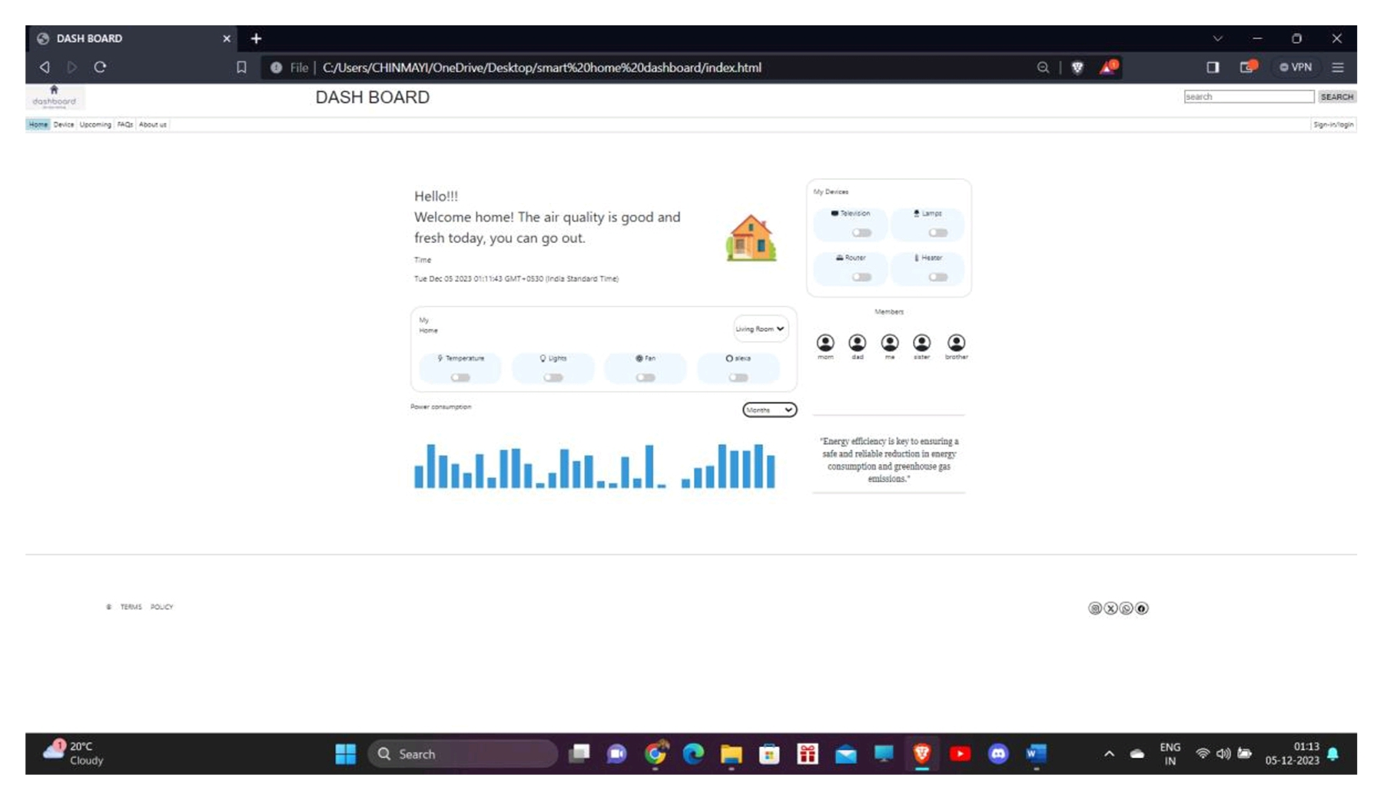

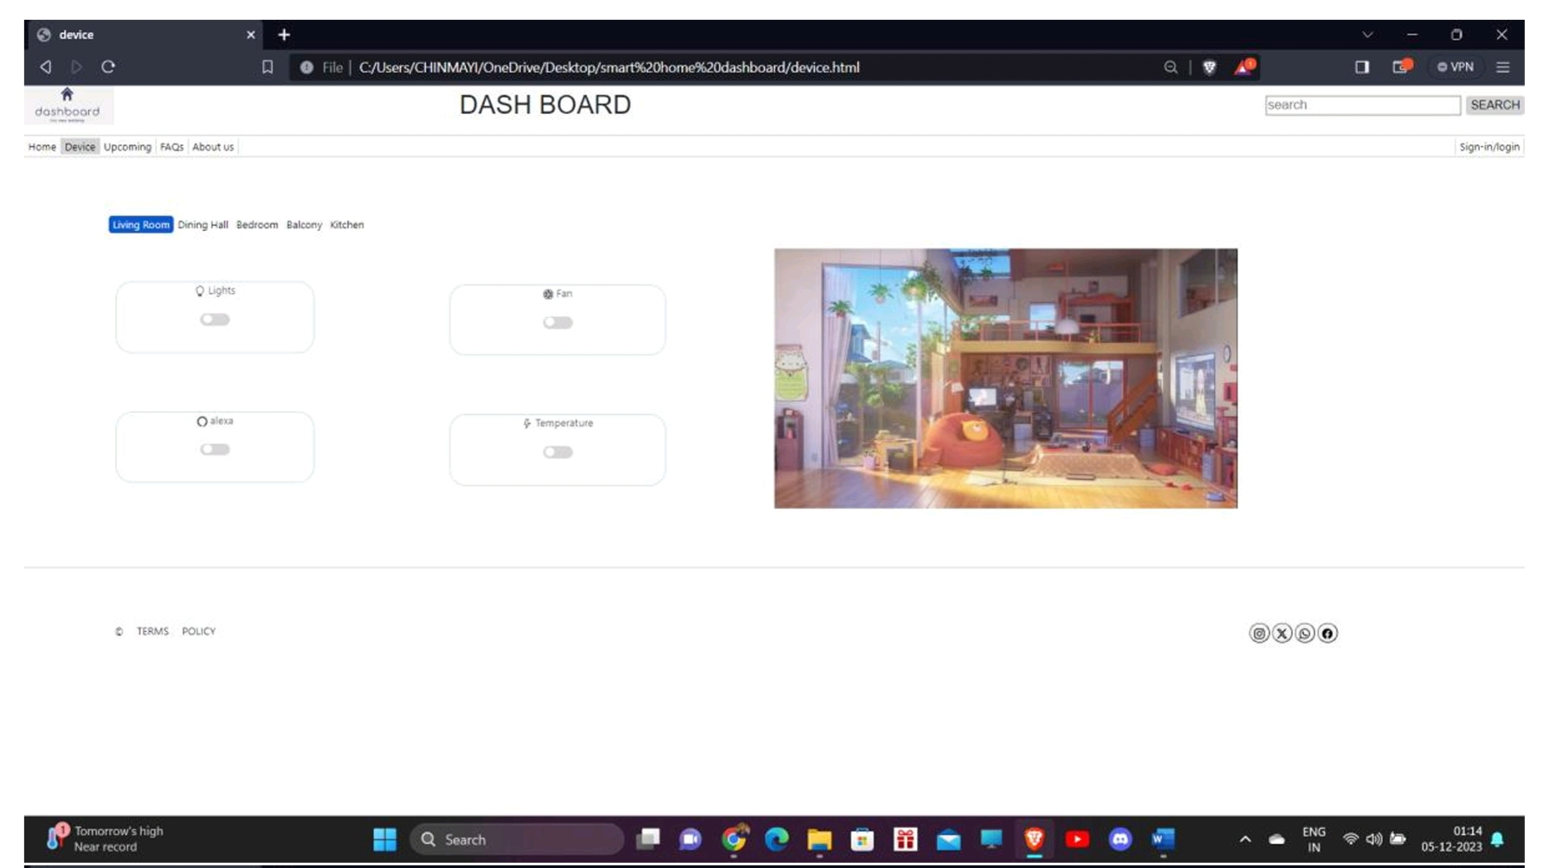

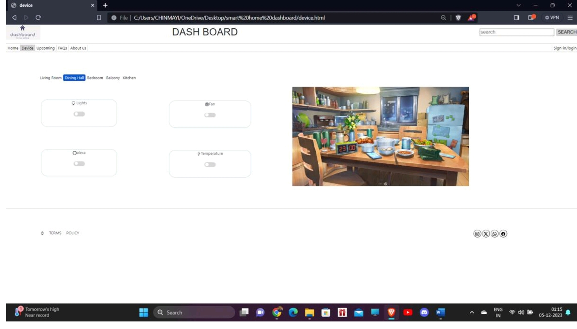

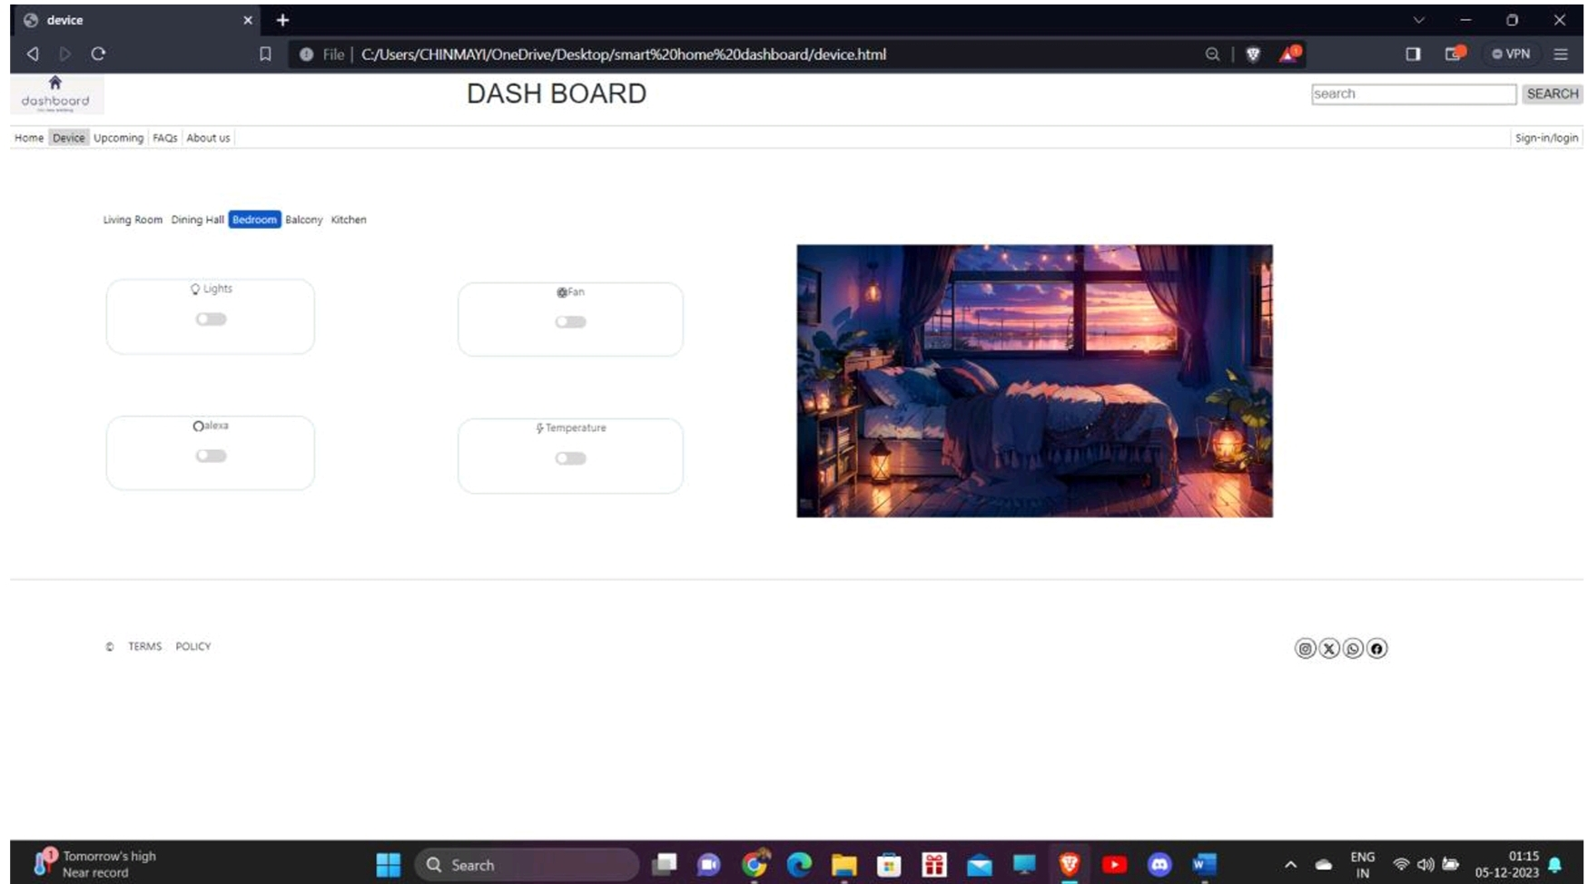

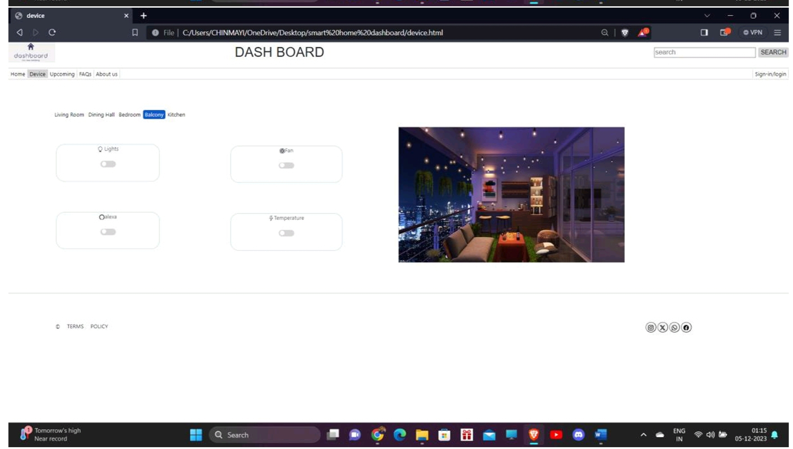

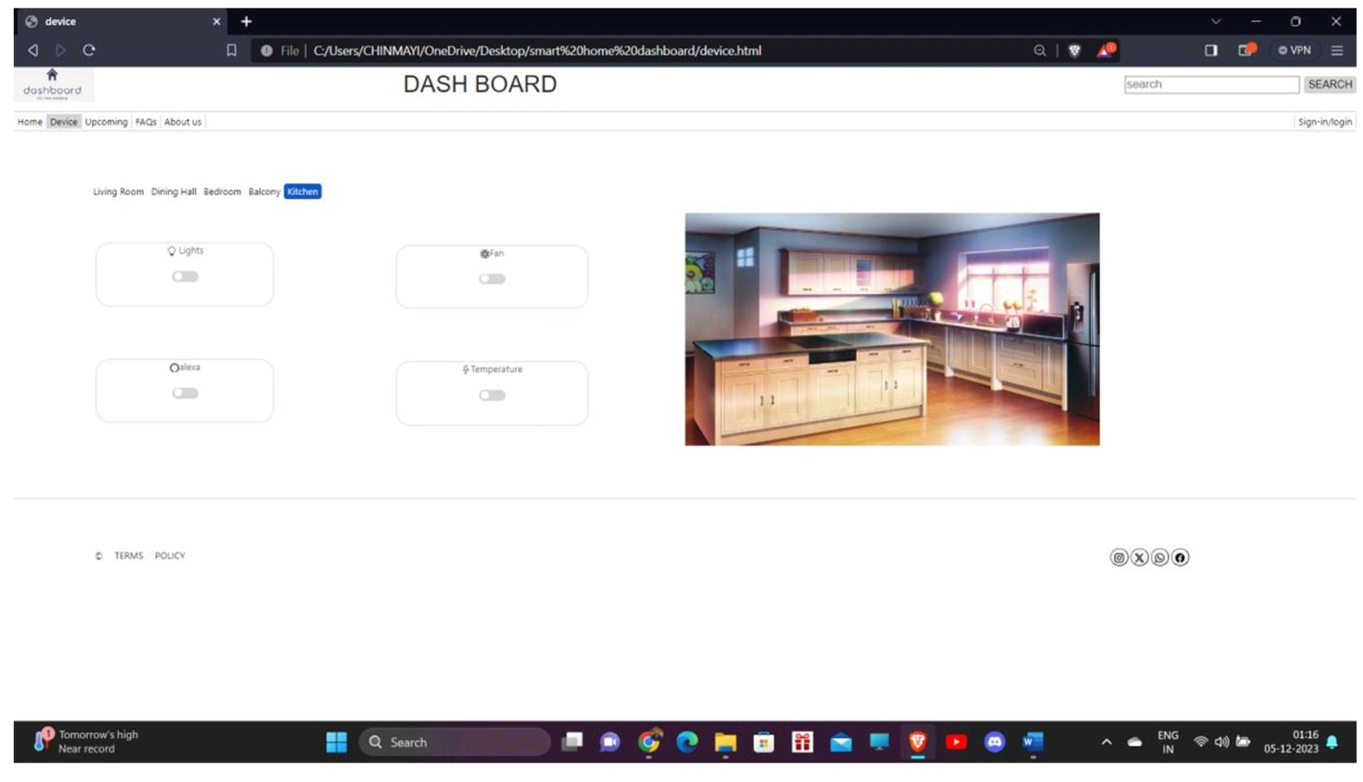

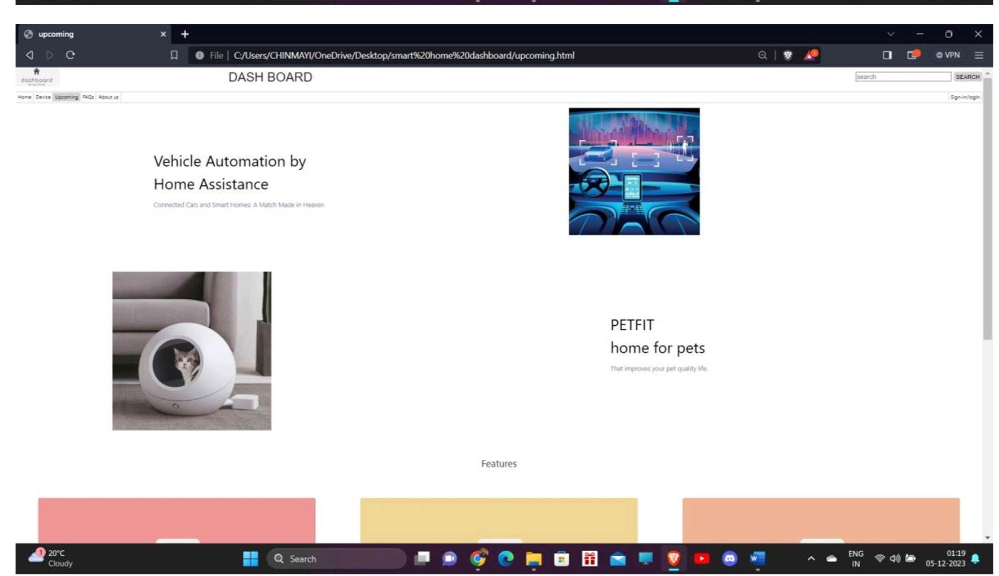

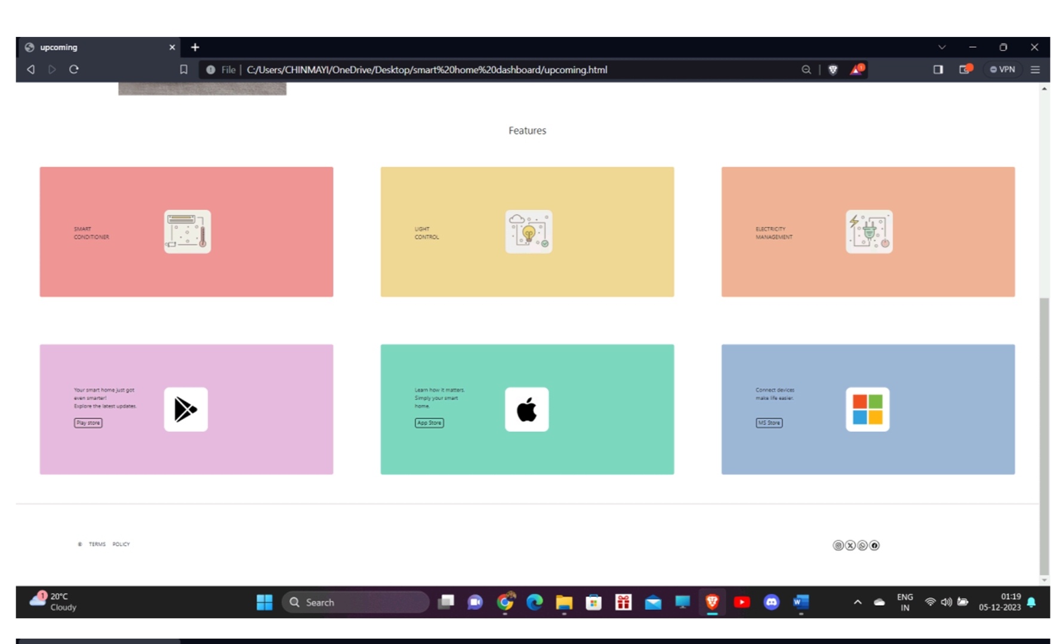

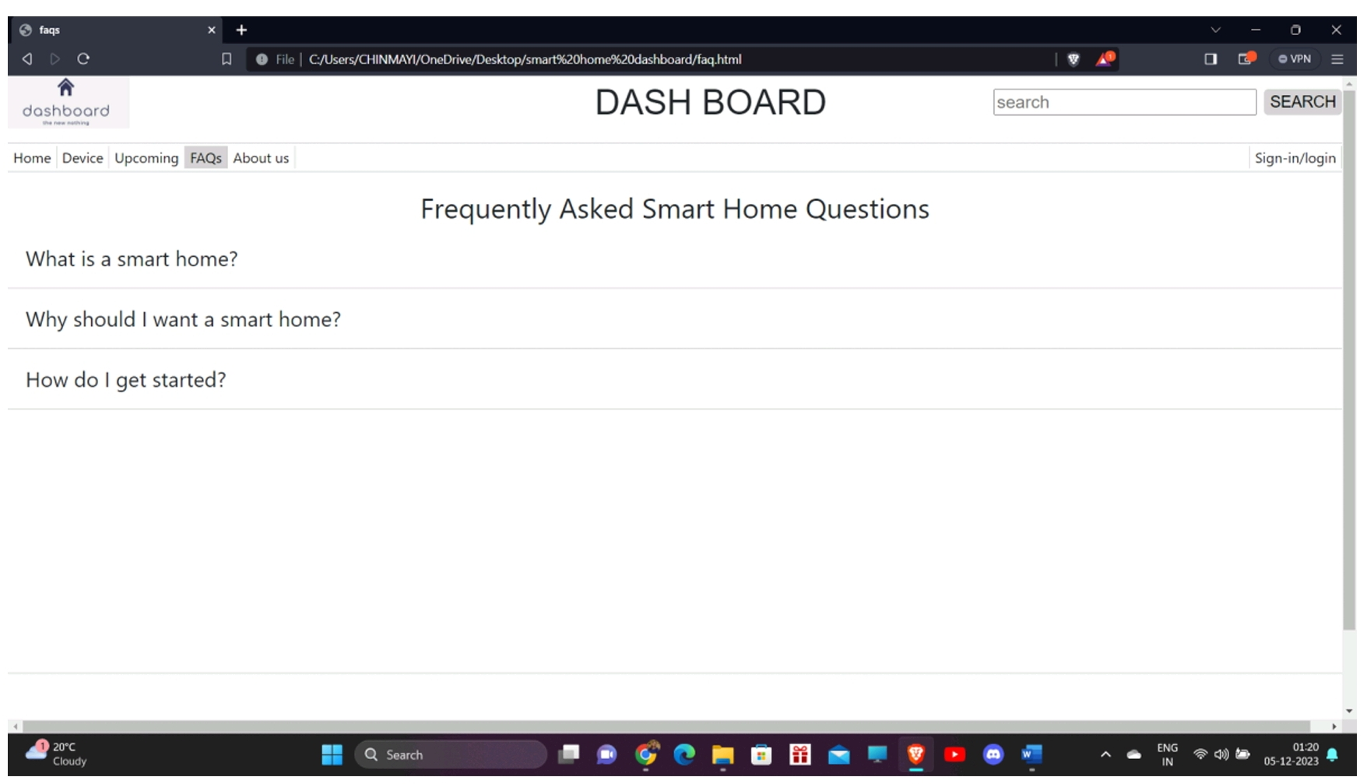

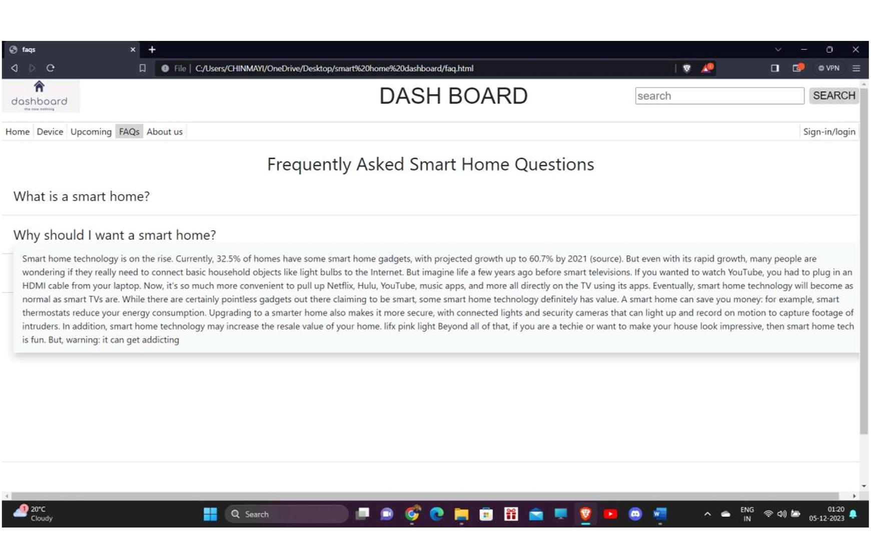

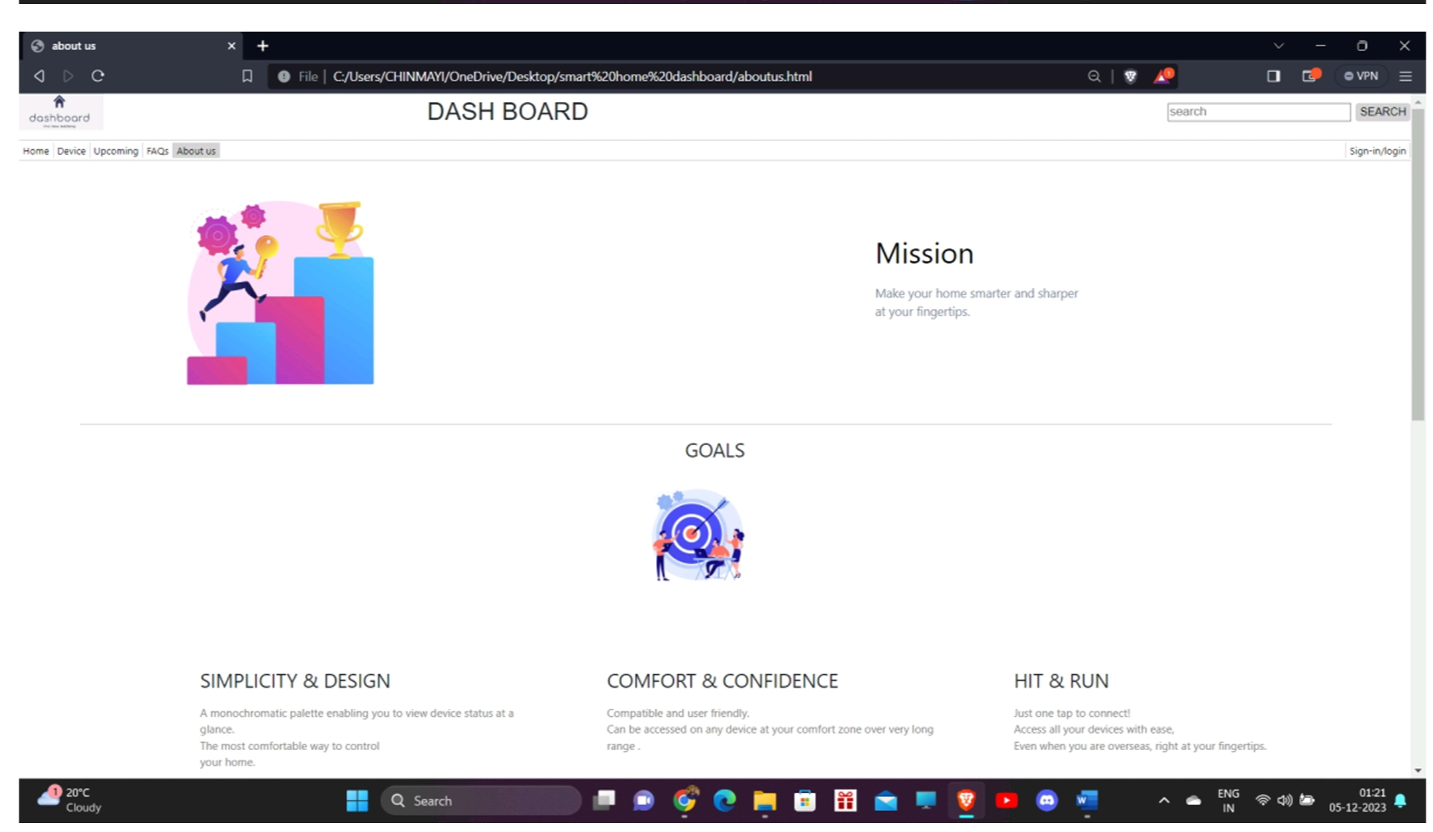

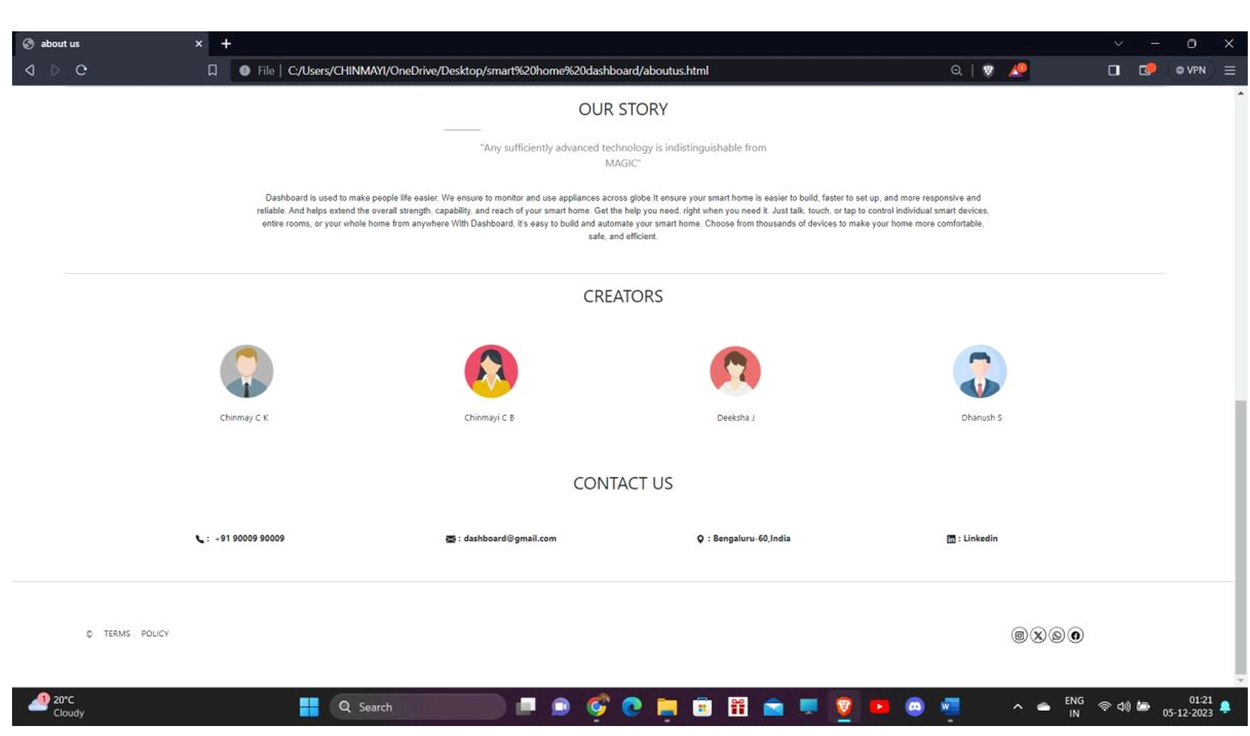

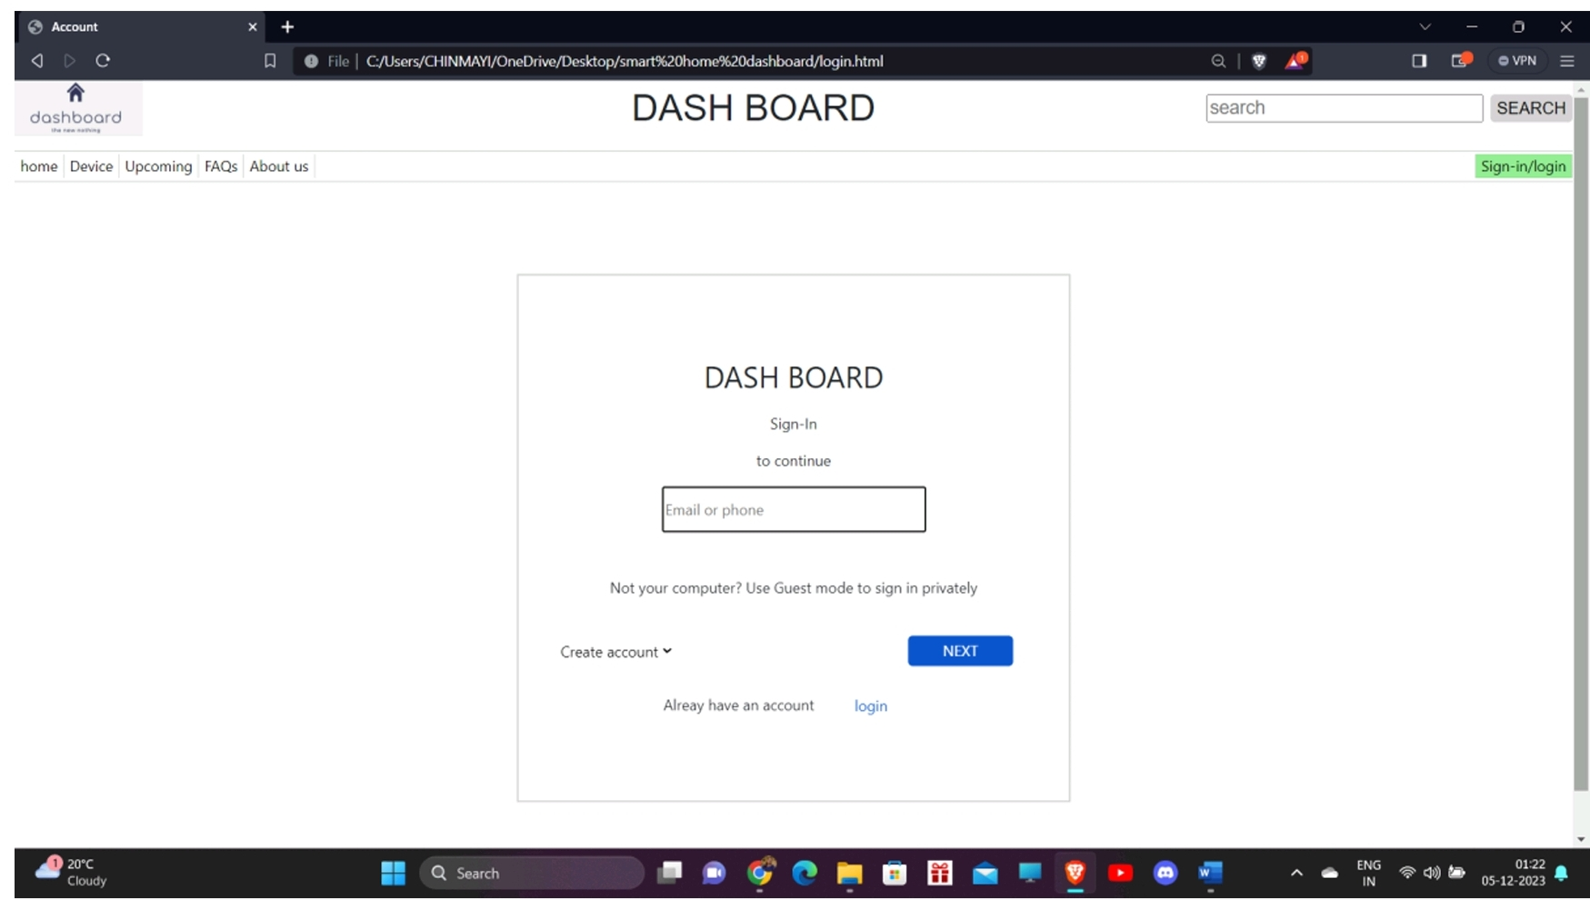

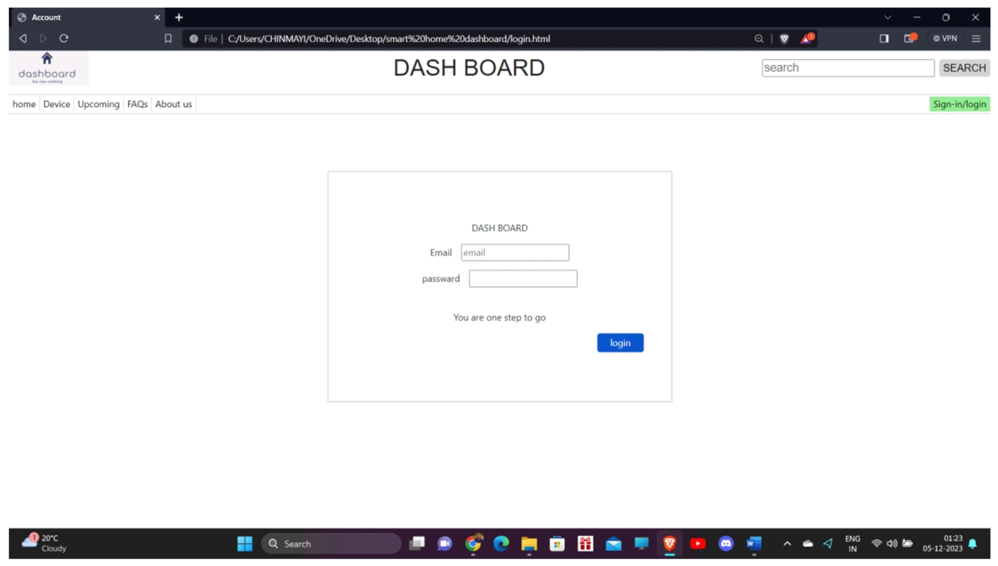

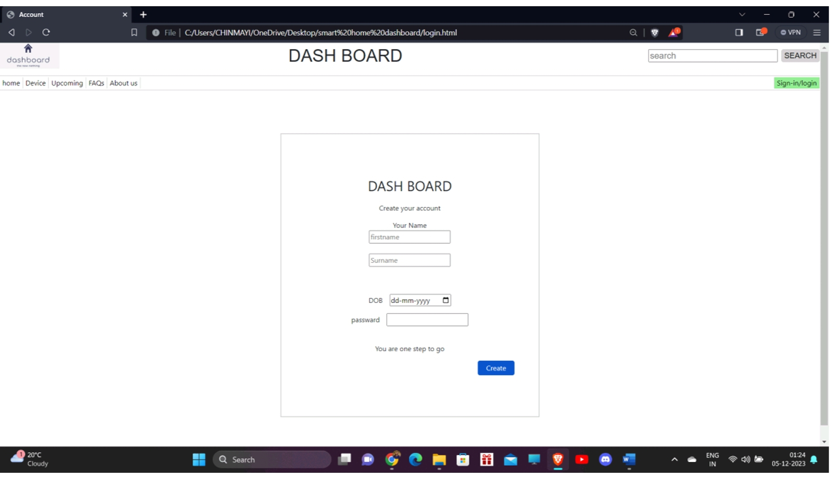

# [CHAPTE](https://1.bp.blogspot.com/-dODuK8N5h1Q/Wlnyb3V9HFI/AAAAAAAACL4/WxQtCJ1pM5wccDABg4wIrTBUB0vlikXQQCLcBGAs/s1600/poly1.jpg)R 9 CONCLUSION

* 1. **CONCLUSION**

Creating a Smart home control dashboard system via full-stack web development represents a harmonious blend of technology, user experience, and data analysis. Here's a conclusive overview:

* **Technological Integration:**
* **Front-end Development:** Crafting an intuitive, responsive interface using HTML, CSS, and JavaScript with modern frameworks for an engaging user experience.
* **Integration with IoT APIs:** Connecting with Internet of Things (IoT) APIs to interact with smart home devices. This includes integration with platforms like Google Home, Amazon Alexa, or specific device APIs for controlling lights, thermostats, security systems, and other smart devices.
* **Core Functionalities:**
* **Device Control Logic:** Developing algorithms to control and manage smart home devices efficiently. This involves creating logic for turning devices on/off, adjusting settings, and handling real-time updates from devices.
* **Automation Rules:** Implement user-defined automation scenarios using rule-based systems or machine learning, enabling intelligent device responses based on specific conditions.
* **User Profiles:** Create personalized profiles to store user preferences and usage history, tailoring the dashboard experience to individual needs.
* **Continuous Improvement:**
* **Testing & Quality Assurance:** Rigorous testing at various stages to validate functionality, usability, and security.
* **Deployment & Maintenance:** Launching the application and providing ongoing maintenance, updates, and bug fixes for an enhanced user experience.
* **User-Centricity:**
* **Personalization:** Customize the dashboard layout and settings to align with individual user preferences, delivering a tailored and user-friendly experience.
* **Engagement & Satisfaction:** Design an intuitive interface for seamless device control, promoting user engagement and satisfaction through reliable performance.

# REFERENCE

1. <https://www.w3schools.com/>
2. <https://dev.mysql.com/doc/>
3. <https://www.mongodb.com/>
4. <https://getbootstrap.com/>
5. <https://nodejs.org/en/docs>
6. <https://developer.mozilla.org/en-US/>
7. <https://docs.djangoproject.com/en/4.2/>
8. https://legacy.reactjs.org/docs/getting-started.html